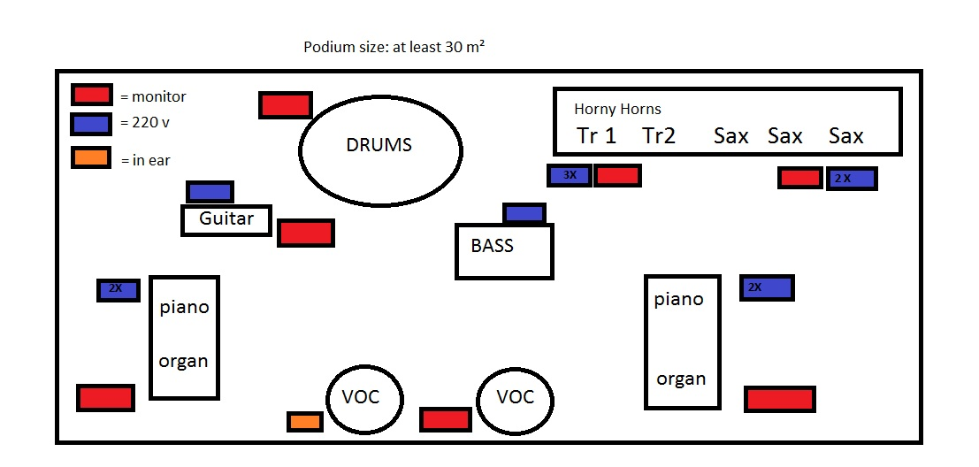
Stageplan Ben-Eih and the Horny Horns

